**AWS Resource Tracker Project Using AWS CLI**

In this project, I am tracking the AWS resources through AWS CLI like how many S3 bucket in your AWS account available, running EC2 Instance, active Lambda Functions, IAM Users.

**Prerequisites: -**

* One Ec2 ubuntu machine
* AWS CLI
* IAM User with Access Key and Secret Access Key

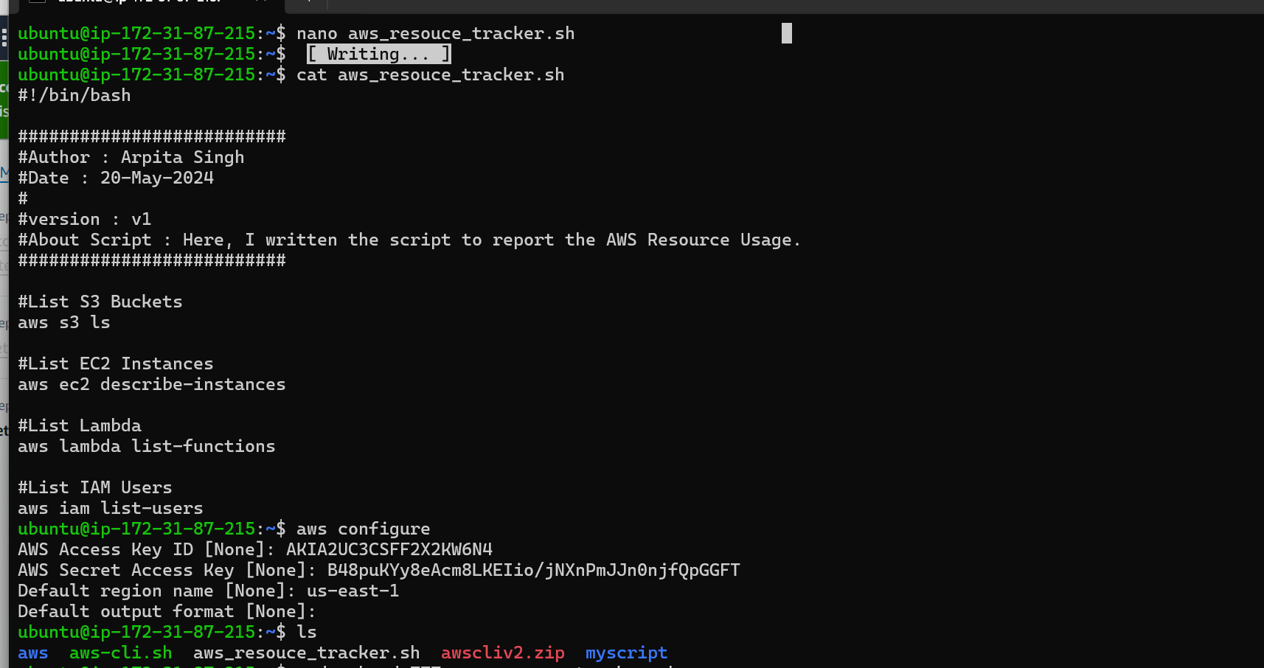

Here, I installed AWS CLI on my ubuntu machine and configure my access and secret access key on machine to interact with AWS through CLI.

I write the script to access S3 Bucket, EC2 Instance, Lambda function, IAM Users present in my AWS Account in **aws_resource_tracker.sh** file and give the executable permission to run the script by default executable permission is not active. Give the executable permission by **chmod +x** **aws_resource_tracker.sh**. After that, I run the script and below it I got the data on **JSON Format** what I ask in script.

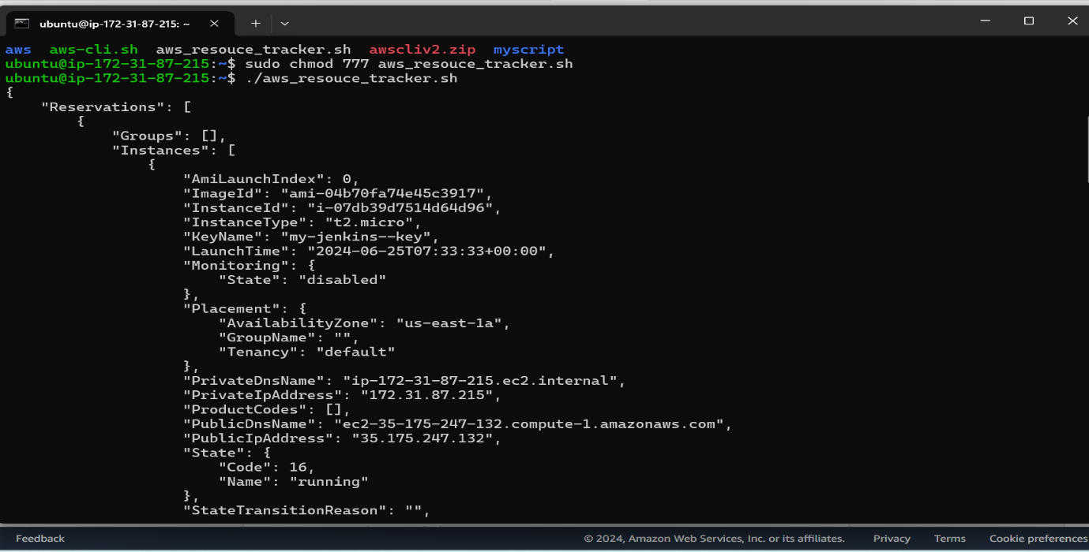

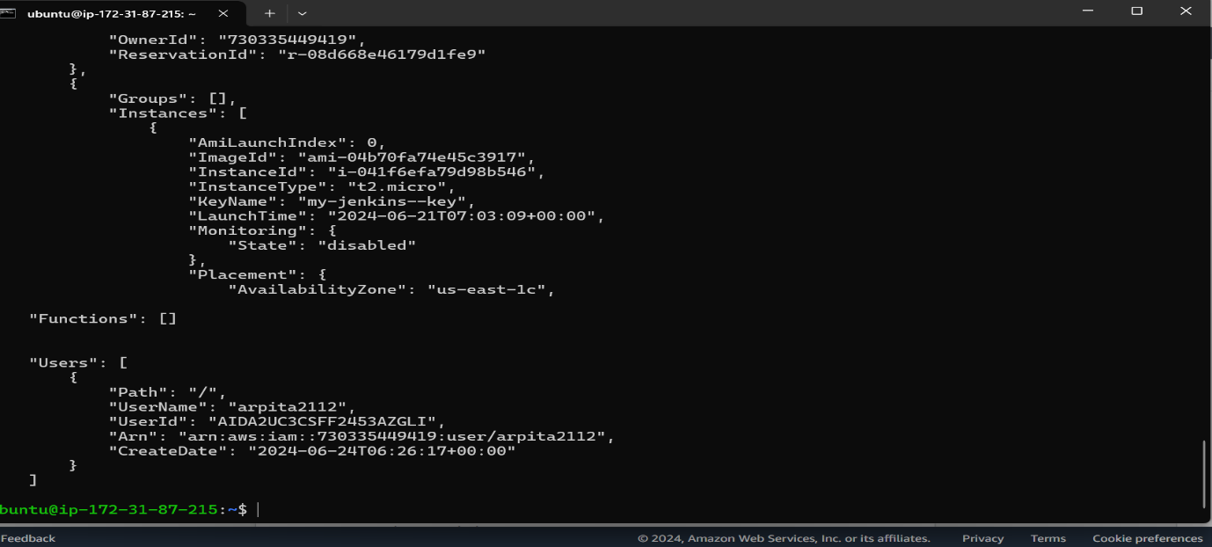

Here, I got the List of EC2 available in my AWS Account, S3 Bucket, Lambda Function, & IAM User.

I don’t have any Lambda function and S3 Bucket active or available so I don’t get any result.

Let use **jq tool** to filter the data more specific like only need EC2 Instance ID, IAM User name so we can use **jq tools** which help me to fetch the data from bunch of JSON data.

So, I use the **jq tools** to get specific details what I want, please find the script in below picture: -

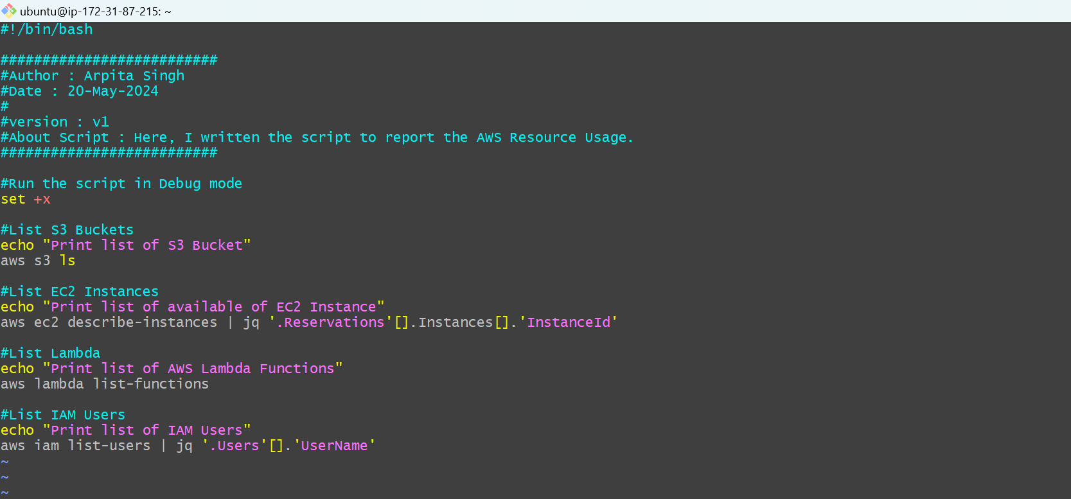

**Here is result what I get after executing this script:** -

